### Six Square Pyramids Can Fit Perfectly into a Cube

|  |
| --- |
|  |
| Six Square Pyramids Can Fit Perfectly into a Cube |

A few years ago, I visited the Great Pyramid of Giza in Egypt with my family. It is one of the seven wonders of the ancient world that is still in existence. It's a remarkable sight to see and a wonder as to how it was built with such precision. One of the many amazing facts about the pyramid is that if you take the perimeter of the pyramid and divide it by twice the height, you get a number that is exactly equivalent to the number pi up to the fifteenth digit - 3.14159265358979. The perimeter of the Great Pyramid of Giza that I found online is 921.25 meters and its original height being 146.64 meters which calculates to 3.1412 (However, I can't find the exact measurements online so I can't verify the above fifteen-digit calculation...if you find them, please email me). Here's a funny way to remember pi up to the fifteenth digit. Count the letters in the words of the following mnemonic:

**How I need a drink, alcoholic of course, after the heavy lectures involving quantum mechanics.**  
  
**The Great Pyramid of Giza measurements are 51° 51’ 14" for its base and 76° 17’ 32" for the vertex...I am noting these measurements for reference. In making this square pyramid with a cube, I used 54° for its base.**

The square pyramids that I created for the Cameo Silhouette have two tabs. They do not need any glue. Repeat this until six square pyramids are created. Tape the pyramids together as shown below.

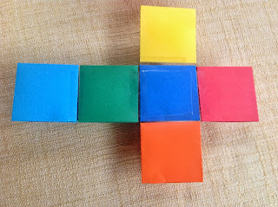

Tape the underside of the square pyramid using five strips of clear packing tape to form a figure as shown.

Next, fold the square pyramids together to form a cube. Below is the finished product with one pyramid left to be placed in cube.

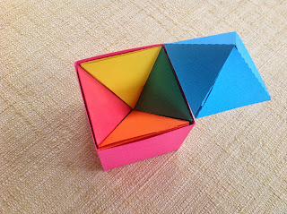

This activity demonstrates volume. Parts of a whole are added together to calculate the total volume of the cube. Remember that the volume of the pyramid is (base x height)/3. After calculating the volume of one square pyramid, you would need to multiply by 6 to determine the total volume of this cube since 6 square pyramids make up this cube.